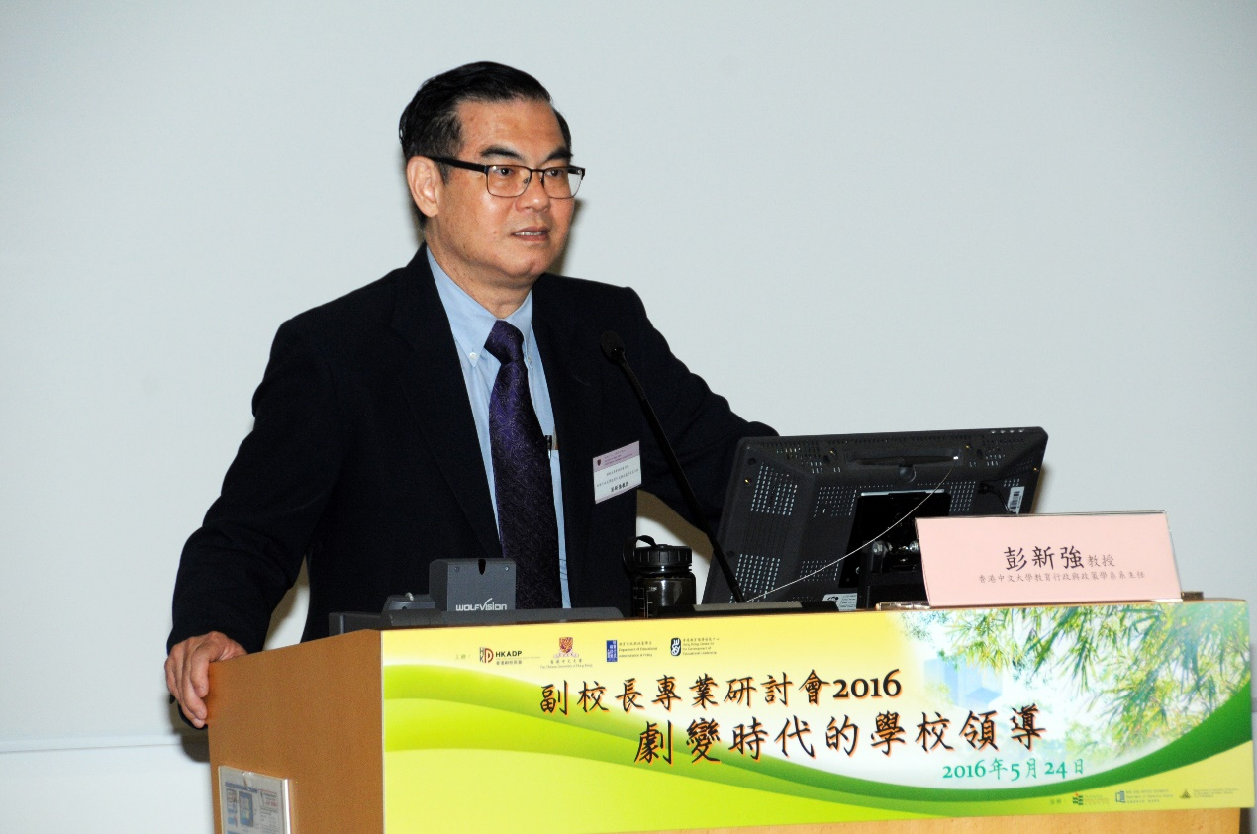

Nicholas Sun-Keung Pang is Professor of the Department of Educational Administration and Policy at the Chinese University of Hong Kong, Hong Kong SAR, China. He was the Chairman of the Department for 2011-2017. He is also the Director of the Hong Kong Centre for the Development of Educational Leadership (HKCDEL). Professor Pang specializes in educational administration, management and leadership, as well as school effectiveness and improvement. He is a sought after presenter and keynote speaker, and has published widely, locally and internationally, with five books, as well as numerous book chapters and internationally refereed journal articles.
Ph: 852-3964 6920 Fax: 852-2603 6761 email: nskpang@cuhk.edu.hk

*****************************************************
Prof. Nicholas Sun-Keung PANG, Ph.D.
Professor
Department of Educational Administration and Policy,
The Chinese University of Hong Kong,
Shatin, N.T., Hong Kong.
Tel: 852-3943 6920 Fax: 852-2603 6761
Email: nskpang@cuhk.edu.hk
Webpages:
http://www.fed.cuhk.edu.hk/~nskpang
http://www.fed.cuhk.edu.hk/eap/
http://www.fed.cuhk.edu.hk/sdet/
*****************************************************

