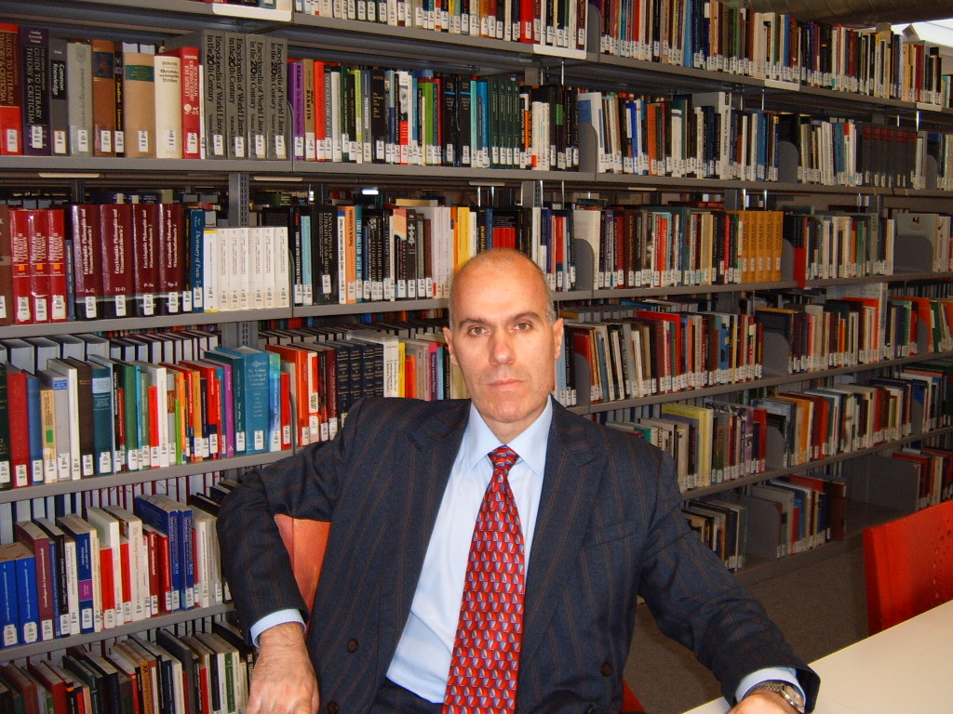

Nikolay Popov is Professor of Comparative Education at Sofia University, Bulgaria. He has two doctorates in Comparative Education – PhD (1990) and Dr.habil (2002). All his teaching and research activities have been focused on the history, theory and practice of Comparative Education. He has conducted comparative studies on management, finance, structures, teacher training, education laws, school curricula and books in various countries. He is author of 25 books and 140 articles and chapters on Education in Bulgaria and Comparative Education.
He is founder and chair of the Bulgarian Comparative Education Society (BCES).

